PGSuper™ Technical Note (TN003)

Girder Sag Warning

# Introduction

The precast-prestressed girder bridge design, analysis, and load rating software, PGSuper™, performs many design checks beyond a basic evaluation of stress and capacity for the LRFD Service and Strength limit states. One check that has been causing engineers concern is the evaluation of the potential for a girder to end up with a net downward deflection, or sag.

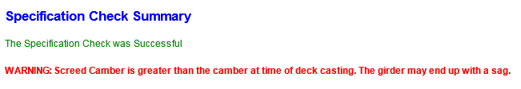

Figure 1 Girder Sag Warning

The purpose of this white paper is to provide information to help the design engineer interpret this design check.

# General

When prestressing strands are placed near the bottom of precast girders, the prestress force imparted into the girder is eccentric with respect to the center of gravity of the girder. When the prestressing effect is sufficient to overcome the deflection due to the girder self weight a net upward deflection called camber results. Camber changes with time (typically increasing) due to creep and shrinkage of the concrete and relaxation of the prestressing strand. A downward deflection occurs when dead load, such as the weight of the wet deck concrete, is applied to the girder. The amount of upward camber and downward dead load deflection must be estimated so that screed rails can be adjusted to the correct elevation and the final position of the bridge deck can meet the desired profile grade.

The terminology used by the WSDOT Bridge Design Office and subsequently in the PGSuper™ software is:

|  |  |  |
| --- | --- | --- |
| D | = | Maximum net upward camber (typically at midspan) immediately prior to deck placement |
| C | = | Maximum downward deflection due to the weight of the wet deck concrete and superimposed dead loads (typically at midspan) |

When C is greater than D, the downward deflection exceeds the upward camber. The net deflection of the girder will theoretically be downward. This condition is commonly referred to as sag.

PGSuper™ evaluates the potential for a girder to sag and issues an overt warning so that this condition is not overlooked. Investigation of the sag condition, its consequences, and possible remedies should be evaluated by the designer.

# Deflection of Precast Girders

The deflection of a precast girder immediately prior to deck casting depends, in part, on the initial camber, deformations due to creep and shrinkage of the girder concrete, relaxation of prestressing strands, and the elapsed time between prestress release and deck placement.

The elapsed time between prestress release and deck placement isn’t precisely known during design. The WSDOT Standard Specifications, 6-02.3(25)K, stipulates that the Contractor shall control the deflections of prestressed concrete girders that are to receive a cast-in-place deck by scheduling girder fabrication between 40 and 120 days before deck placement on the erected girders. That is, the girders should be anywhere between 40 and 120 days old at the time of deck placement. The bridge design must accommodate the range of camber that can occur between 40 and 120 days.

In addition to accommodating a range of camber for uncertainty in the construction schedule, accommodations must be made for natural camber variation. It is well known that two identical girders will have different initial camber and camber growth over time. This natural variation is a result of many factors including tolerances of girder dimensions, strand placement and prestressing force; variations in the composition of the concrete; curing conditions including temperature and duration; and environmental conditions including ambient temperature and relative humidity. Camber can vary as much as ±25% from the mean value. To accommodate natural camber variation, upper bound, average, and lower bound cambers are predicted. Lower bound cambers are taken to be 50% of the upper bound values based upon empirical observations.

The range of camber at the time of deck placement can be anywhere between the lower bound camber at day 40 and the upper bound camber at day 120. This range of camber is shown in the girder schedule to alert the Contractor of expected girder haunch variations and deck concrete quantities.

The downward deflection of the girder due to the weight of the wet deck concrete and superimposed dead loads is computed based on classical elastic analysis. The dead load of the wet deck includes the girder haunch. The haunch fills the space between the top of the girder and the bottom of the deck. The shape of the haunch depends on girder camber at the time of deck placement and the deck profile. Since camber varies from zero at the girder supports to D at midspan, it is conservatively taken to be zero over the entire length of the girder when computing haunch weight. The downward deflection is computed using the modulus of elasticity of the girder concrete based on its specified 28 day strength.

The screed rails for the deck finishing machine must be adjusted upward by an amount equal to the downward deflection due to the wet deck and superimposed dead loads. The adjustment is called the screed camber and is denoted by C at midspan.

A comparison of C to D is sufficient to determine if a girder has the potential to sag.

# Determination of Sag Potential

The screed camber, C, is compared to the deflection at the time of deck placement, D, to determine if a girder has the potential to sag. Theoretically, sag will occur when C is greater than D.

As explained above, there are several D values that capture the range of possible camber at the time of deck placement. The screed camber is compared to the upper bound, average, and lower bound D values for deck placement at 40 and 120 days.

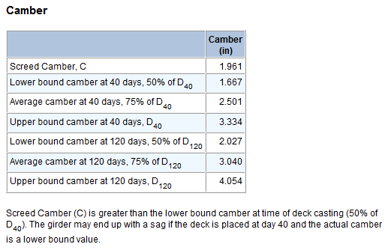

Figure Comparison of Screed Camber and Camber

If C exceeds the lower bound camber at 40 days an informational message is reported by PGSuper™. It is extremely rare that lower bound camber will occur for a girder that is erected and has the deck placed on day 40. Lower bound camber is typically associated with extended curing of the girder concrete such as would occur over a holiday weekend. Deck placement at 40 days is typically associated with rapid construction. Extended curing time and rapid construction typically do not occur together. Nevertheless, the design engineer is alerted to this condition because it is theoretically possible.

PGSuper™ will report a warning message if C exceeds the average camber at 40 days or if C exceeds the upper bound, lower bound, or average camber at 120 days. The warning alerts the design engineer to the possibility that the girder may sag.

The design engineer should evaluate the sag warning. In cases where sag potential exists for deck placement at 40 days it may not be a serious issue. In fact, the girder might not sag at all if the actual camber is greater than the average value or if the deck is placed closer to day 120 than to day 40. On the other hand, if there is sag potential for deck placement at 120 days there may be problems with the design.

It is known from many years of experience that sagging girders are not a wide spread problem. Designers should not be overly alarmed when PGSuper™ reports a possible sag condition. The warning simply alerts the designer to the possibility that a girder could sag under certain conditions. The true purpose of the warning is to get the designers attention and encourage thoughtful consideration of the realistic sag potential, the consequences that may result and whether design alterations are warranted.

# Assumptions

The camber and deflection calculations performed by PGSuper™ are based on some conservative assumptions. These assumptions are:

* Modulus of elasticity is based on the specified 28 day concrete strength. The actual modulus may be higher resulting in less deflection then predicted.
* Composite section properties are based on the deck being placed directly on top of the girder. The haunch is assumed to be non-existent. The actual position of the deck may be offset from the top of the girder. The actual bending stiffness of the girder may then be greater than computed resulting in less deflection due to superimposed dead loads than predicted.
* The depth of the deck haunch varies along the length of the girder due to camber and deck profile. For purposes of estimating dead load effects, the girder is assumed to be flat and depth of the haunch varies only to accommodate the geometry of the roadway profile. The actual dead load of the haunch may be less resulting in less deflection due to the wet deck than predicted.

# Girder Sag Remedies

There is no one correct remedy for girder sag. Sag conditions must be evaluated on a case by case basis. Here are some things to consider:

* Why is PGSuper™ issuing the sag warning? What is the root cause of the warning?
* Is the possibility of sag only for the rapid construction scenario (deck placement at 40 days) or might the girder sag for the normal construction scenario (deck placement at 120 days)?
* How likely is the rapid construction scenario for this bridge?
* Sag doesn’t necessarily mean structurally deficient. How much sag can the bridge tolerate?
* Can the girder structurally support the additional deck haunch dead load from sag? Since PGSuper™ calculates deck haunch dead load assuming the top of girder is flat; sag will add additional haunch dead load that will be unaccounted for by PGSuperTM. The additional dead load can be modeled with the User Defined Load feature of the software.
* Are there aesthetic concerns with sag? Will the sag be perceptible to the traveling public?
* Will sag create drainage (ponding) issues?
* Can the deck match the desired roadway profile if there is sag?
* Is a reduction in vertical clearance due to sag a concern?
* What other issues might arise if there is sag?

Here are some things to consider in situations where it is desirable to modify the design to reduce or eliminate the sag potential:

* Adding prestressing can increase camber. However, it will also increase tension in the top of the girder and increase the concrete strength requirement at release.
* Deeper girder sections, closer girder spacing, and/or shorter span length can reduce deflections.
* Girders can be pre-cambered by cambering the girder formwork before placing girder concrete.

# Features related to Sag Warning

PGSuper™ has several features that control the camber variability and the evaluation of sag potential. The settings for these features are in the Project Criteria Library so that agency-specific default values can be established and shared throughout the design office and with consultants.

The Creep and Camber tab has the camber variability setting. This setting establishes variability between the upper and lower bound camber.

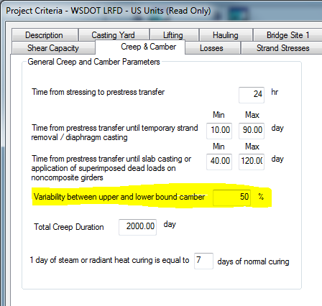

Figure 3 Camber Variability Setting

The Limits and Warnings tab has settings to control when girder sag warnings are issued. The warnings can be completely disabled. When enabled, the warnings can be based upon upper bound, average, or lower bound camber.

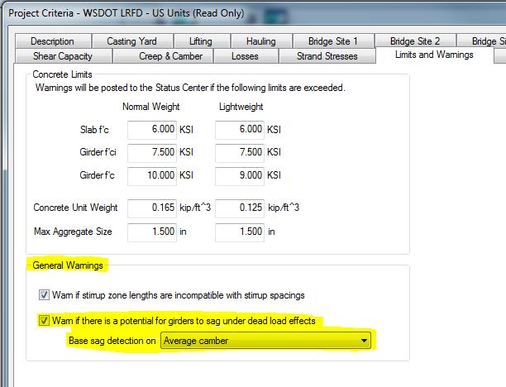

Figure 4 Sag Warning Options

# Summary

The girder sag warning has been a source of confusion for design engineers. It is known from many years of experience that sagging girders are not a wide spread problem. The purpose of the sag warning is to alert the designer to the possibility of girder sag and to encourage thoughtful consideration of the realistic potential, consequences and remedies for girder sag. Designers should not be overly alarmed when PGSuper™ reports a possible sag condition.